[*Sustainable Practice – AIE and Beyond*]

[Academy of Interactive Entertainment]

[Environmental Impact Report]

[ 03 / 08 /2017]

# Context, scope and rationale

**What is the Proposal?**

*Briefly describe here the scope of the Project.*

**Management actions to be implemented**

Identify key risk areas that can be addressed with sustainable practice at a typical game studio or AIE itself. For each area identify the risk it currently presents, the impact it will have and then propose an action to reduce this impact. A risk-based priority will be assigned to the action based on the risk that action possess to the business objectives of the organization. An example is presented below.

**Fill the blanks:**

|  |  |  |  |
| --- | --- | --- | --- |
| **Risk and key impacts** | **Management actions** | **Risk-based priority** | **Timeframe/**  **Project phase** |
| Lighting energy consumption  - Impacts power bill | Install energy saving globes  Install timer mechanisms to ensure lights are off after hours | Low | 1 month |
| Loose cables,  - Impacts staff & students (WHS risk, Injuries etc) | Tape down cables, tidy work area's Implement safety signs | Medium | Ongoing |
| Faulty Chairs - WHS risk, Injuries | Replace faulty chairs | Low | 1 week |
| Student Bullying - Causes stress to Students and/or Staff | Disciplinary actions  Student separation | High | Ongoing |

**Table 1 Risk-based Management Actions that will be implemented to meet the condition environmental objectives**

# Stakeholder consultation

Consistent with business practice, AIE consulted with stakeholders while developing this report. This section provides a summary of consultation that occurred. The comments raised during consultations with stakeholders were considered in the development of this report. The following sections present stakeholders’ comments and [*Example Company’s*] responses to those comments.

|  |  |  |
| --- | --- | --- |
| **Organisation(s)** | **Comments** | **AIE Response to Comments/Concerns** |
| Imaginary Investor inc. | Fully support move to hypothetical efficient render farm | Also support move, will go ahead as planned. |

**Table 2: Stakeholders consulted, comments and responses**

# Energy Audit

Consistent with business practice, AIE has conducted an energy audit and recorded medium to high impact items in the following section. This section provides a summary of the energy calculations used and final results obtained.

# EA 1) Power consumption of three items in AIE’s work place

Items tested: Laptop, Computer Tower, Computer Monitor

Items will only provide their voltage and current consumption rather than their power directly. Power can be calculated from these values using the formula,

𝑃𝑃𝑃𝑃𝑃𝑃𝑃𝑃𝑃𝑃 = 𝑉𝑉𝑃𝑃𝑉𝑉𝑉𝑉𝑉𝑉𝑉𝑉𝑃𝑃 × 𝐶𝐶𝐶𝐶𝑃𝑃𝑃𝑃𝑃𝑃𝐶𝐶𝑉𝑉

**Example**



In the image above the output reading specifies **19.5 Volts**, and **7.7 Amps**.

Therefore, the power consumption of this device is,

Power = 19.5 × 7.7

Power = 150 Watts

# EA 2) Conversion of the obtained power value to kilowatt-hours

In order to give a meaningful value to our power consumption, it’s converted to ‘Kilowatt-hours’.

**To convert a value to kilowatt-hours:  
 Take the power value (Watts) and divide it by 1000, the answer is its conversion to kilowatts.**

Eg. 150 Watts becomes 150/1000 which is 0.15 kilowatts (kW).

**The hours component in kilowatt-hours refers to the time (hours) we intend the device to be on.**

Eg: If the laptop was on for 24 hours, it’s kW value (0.15 kW) is multiplied by 24.

150 Watts becomes 150/1000*24 = 3.6 kWh

**This is a valuable figure as power companies charge in kWh**

# EA 3) Calculate cost over a month

Assume that the power company is charging a flat 17c per kWh of power consumed.

If the 24 hours of power consumption (0.15kW * 24 = 3.6kWh) is multiplied by 30 (days in a month), that value can be multiplied by the hourly cost of electricity (0.17c) to work out an estimate of the power consumption cost for a month for that particular device.

Eg. 3.6kWh * 30 days * $0.17 = $18.36

**Result: The laptop can be left on 24/7 for the cost of $18.36 p/month.**

**Repeat this calculation for each of the items identified in the table below, write the answers in ‘Cost of Running Item for a Month’.**

|  |  |  |  |
| --- | --- | --- | --- |
| **Item** | **Power consumption**  **(W)** | **Power consumption over 24 hours (KWh)** | **Cost of running**  **item for a month ($)** |
| Laptop | 150 W | 3.6 kWh | $18.36 |
| Computer Tower | 400W | 9.6 kwh | $48.96 |
| Computer Monitor | 75 W | 1.8kwh | $9.18 |
| Logitech Speakers | 200W | 4.8kwh | $24.48 |
| Total | 825w | 19.8Wh | $100.98 |

# EA 3) Calculate CO2 emissions

The figure below is used to calculate the CO2 production using the value for your state.

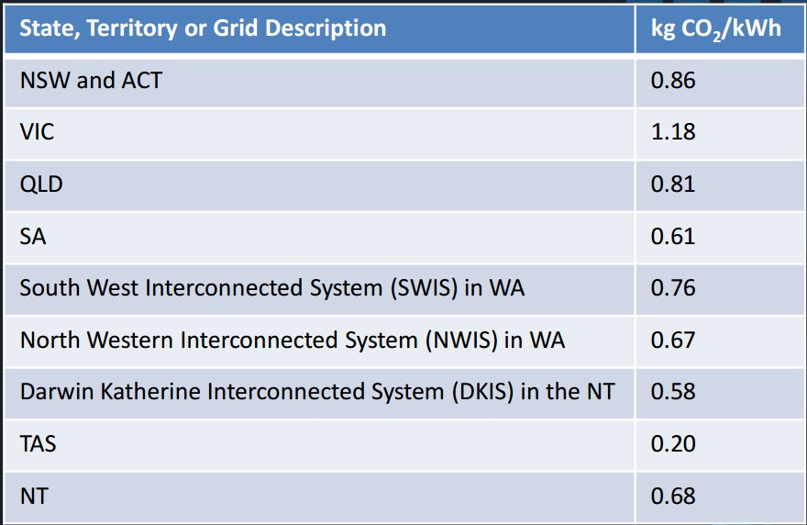

Eg: Power consumption (kWh) is multiplied by the state value from the figure above.

3.6 kWh x 0.86 for NSW

**Result: 3.096 kg of CO2 a day to run the laptop.**

For a yearly value, multiply by 365 (days)

**Eg. 3.096 kg x 365 days**

**Result: 1130 kg of CO2 p/year for the laptop**

Note for comparisons sake: Power plants produce approximately 9.795 giga-tonnes each year.

**Repeat this calculation for each of the items you identified in the previous table, and write the answers on the next page:**

|  |  |
| --- | --- |
| **ITEM** | **Co2 Emissions p/Day**  **(kg)** |
| **Laptop** | 3.096kg |
| **Computer Tower** | 8.256kg |
| **Computer Monitor** | 1.548 |
| **Logitech Speakers** | 4.128kg |

**Table 3: Energy Audit Table**

## Identified Solution to Medium to High Risk Items

AIE as a business dedicated to sustainable work practice has identified the following proposed solutions to mitigating the impact of the medium to high risk items identified in this report.   
**Fill out the blanks:**

|  |  |
| --- | --- |
| Identified item requiring action | Identified solution |
| High energy 150W globes still in use | Globes to be replaced with low power LED alternatives using 30W. |
| Projectors using excessive power | Regulate projector usage  Find more efficient models |
| Computers are left on overnight/weekends | Turn-off policy stressed with students – Cannot leave on the 5 o clock unless your computer is turned off |
| Building aircon outdated/using excessive power | Replace aircon |

**Table 4: Proposed Solutions Table**